**Component Name**: Switch Theme Component

**Component Functionality**:

The main moto of this app is that we can switch the theme type (light/dark) to change the colour scheme of the complete application. As soon as the page loads, we display the page in light theme. When the theme switch toggle is clicked it changes the theme to dark mode, which changes the overall colour scheme of the page. When the toggle button is clicked again, it will change the colour scheme to the light mode.

**Usage Areas**:

It is a reusable component which can be used wherever a light/dark theme switch is required in any application.

**Component Technical details**:

* Angular cli version 8.3.8
* Typescript version 3.5.3

**How this component can be integrated with other Applications**:

We can refer code / utilise same code to integrate theme switch functionality. For reusability theme folder should be taken as is and corresponding changes should be made in

App Module and App Component.

**Screenshots**:

1. **Light Theme:**

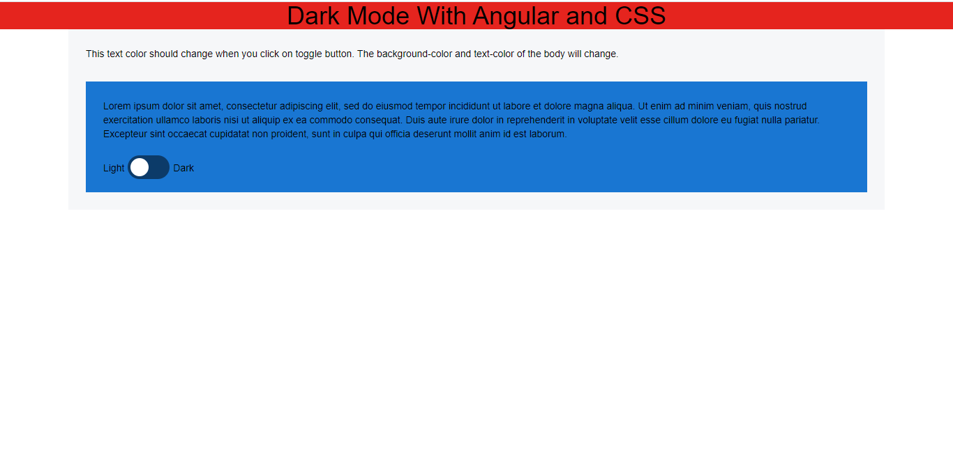

1. **Dark Theme:**

